In this tutorial we will be making a behaviour to have an object follow around the “player” In unity

1. To start off create a new project and make a plane, this plane will be used as the floor
2. Now create two GameObjects do this by going to GameObject 🡪 3D Object 🡪 Cube/Sphere for this tutorial I have chosen a cube GameObject as the player and a sphere as the object that will follow (Be sure to name the objects Player and Follower to help make things neater and easier)
3. **This part we will be working on the follower** Select the follower object and in the inspector go to Add Component 🡪 Search for RigidBody and add it as a component (do not confuse it for RigidBody2D)
4. Now create a new script for the object to do this go to Add Component now you can either search for add script or type in the name of the script you want to create, Unity will not recognize the name and will give you an option to add a new script this will then name the new script you are making into Follower, once it gives you the option click on “Create and Add” this will create the script and attach it to the follower for you.
5. Below is the follower script that will be attached to the follower game object

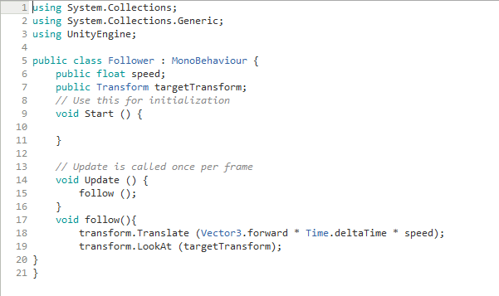

This allows the follow code to run every frame since it is under void update

This allows the follower to move forward at the speed that we have set it.

This will make the follower always look towards the player.

This sets the speed of the GameObject.

This stores the location of the player GameObject.

1. **Be sure to save the script and make sure there are no errors** now going back into unity select the follower game object scroll down the inspector until you are now at the script there should now be “Speed” and “Target transform” Put it any number for speed, pick one that best suites you, if you think the follower is moving too fast lower it and etc
2. For the “Target Transform” part click on the circle at the far end of the of it to bring up a list, in this list there should be a list of Scene Objects, click on the Square Game Object which we have named “Player” or just drag the name from the hierarchy straight into it to set the target as the player”
3. **You are all done!** Press the play button and you should see the follower moving towards the Player GameObject, to play around with it go onto “Scene” while the game is playing and move the Player object around and you will see that the Follower Game Object will try and follow it (If you want the Game Object to be able to fly and defy gravity to reach the Player simply tick the “Is Kinematic” option in the Rigidbody component of the follower GameObject”